**VIT UNIVERSITY: VELLORE**

SCHOOL OF INFORMATION TECHNOLOGY AND ENGINEERING

MS-SOFTWARE ENGINEERING

FALL-2013

**PROJECT REVIEW REPORT II**

**Project Title: SMART ATTENDANCE**

SUBMITTED BY

NAME(S) REG.NO(S) SIGNATURE OF STUDENTS

……………………. …………………… …………………………………………

A.Sai Praneeth 10MSE0066

G.Dinesh Chowdary 10MSE0018

**EVALUATED BY**

NAME AND SIGNATURE OF PANEL MEMBERS

1.

2.

3.

**1.0 Detailed Design:**

**1.1 Modular Design:**

**1.1.1 *User Authentication Module:***

* + - Requires Username and Password.
    - When requested, calls web service.
      * If Response = “SUCCESS” then Calls subjects list.
      * Else Remains on same Page.

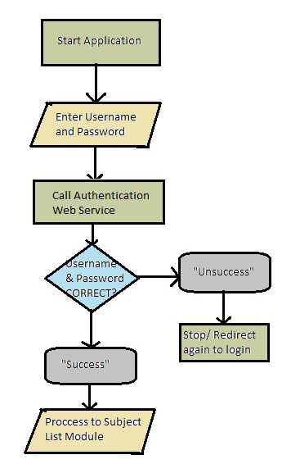

**1.1.2 *Subject List Retrieval Module :***

* + Requires Username.
  + Calls a PHP Script and retrieves all subjects in database.
  + Return data in Json format.
  + Json format is parsed in Android.

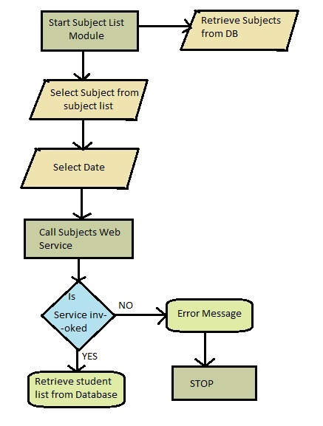

**1.1.3 *Student List Retrieval Module:***

* + Requires Faculty name (username) and Selected Subject.
  + Request PHP Script and retrieve students in Database.
  + Returns Data in Json Format.
  + Json format is parsed in Android.

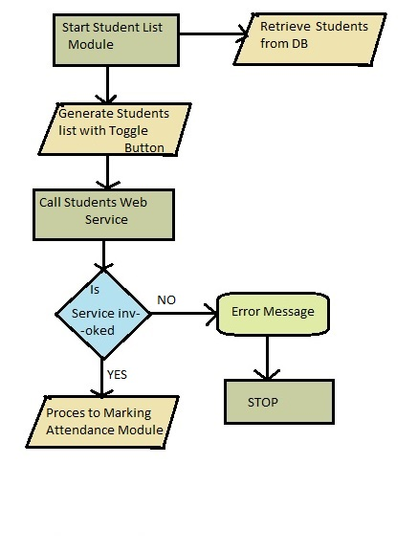

**1.1.4 *Marking Attendance Module:***

* + Displays each student name along with a Toggle button.
  + Faculty marks attendance.
  + Stores all details in Database.

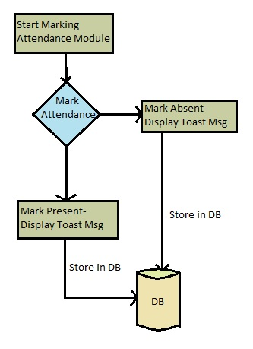

**1.1.5 *Display Student Information & Message Intimation Module:***

* + **Displays all Students information in three Categories...**
    - **Students >= 75% Attendance.**
    - **Students < 75% Attendance.**
    - **Students absent for more than 2 classes**
  + **Sends Intimation message to parents and Students.**

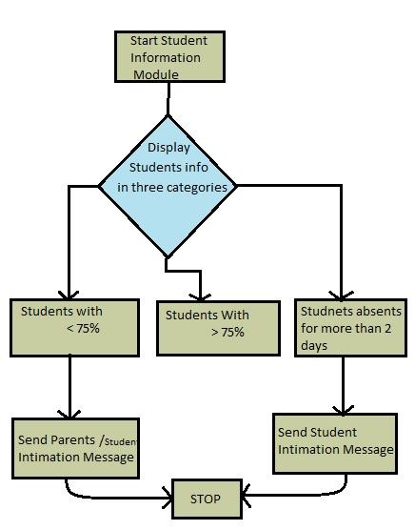

**2.0 DESIGN:**

**2.1 *Use Case Diagram:***

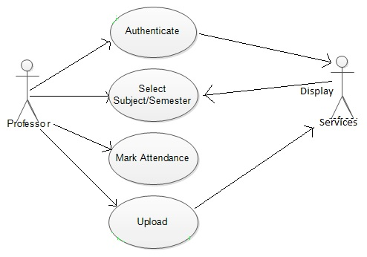

**2.2 *Class Diagram:***

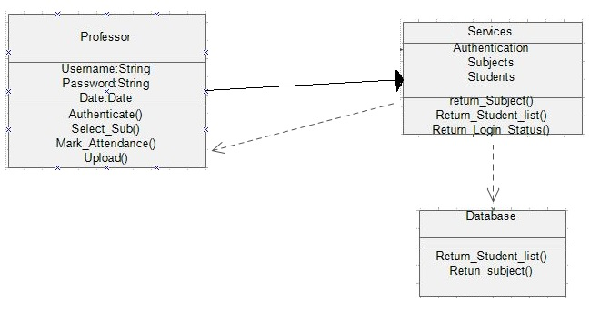

**2.3 *Sequence Diagram:***

